2520030413
1)

Step – 1: Open PowerShell as Administrator
- Press Windows.
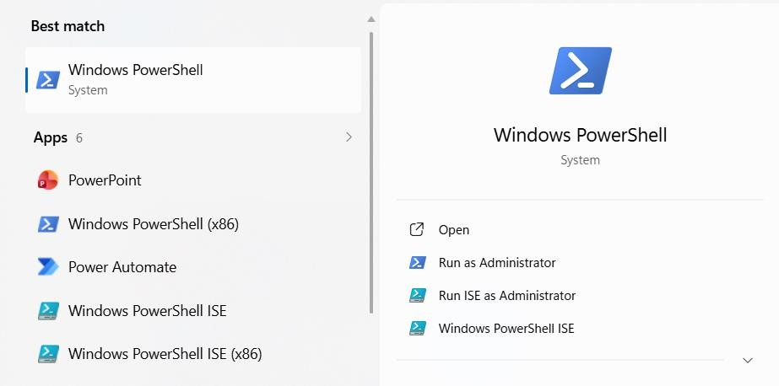
- Search for PowerShell.

- Right-click Windows PowerShell.
- Click on "Run as Administrator".

Step – 2:
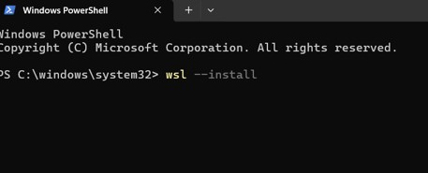

Step – 3:
After installation, restart your PC when prompted.

Step – 4:

After restarting:
- Ubuntu opens automatically (or search for Ubuntu in the Start menu).
- Wait for the installation to finish.
- Create a Linux username Ex:
Enter new UNIX username: kavya

Step – 5: Create a Password
You'll then be prompted to create a password. New Password: ***
Retype New Password: ***

Step – 6: Update Ubuntu
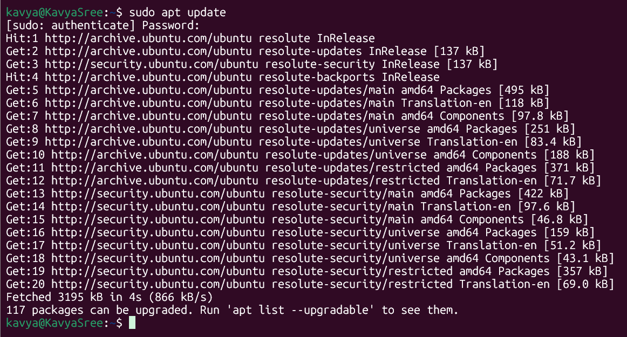

Step – 7: Install GCC (C Compiler)
Install the GCC Compiler and required development tools using: "sudo apt install build-essential".

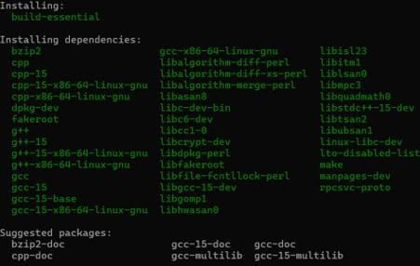

Step – 8: Verify the Installation
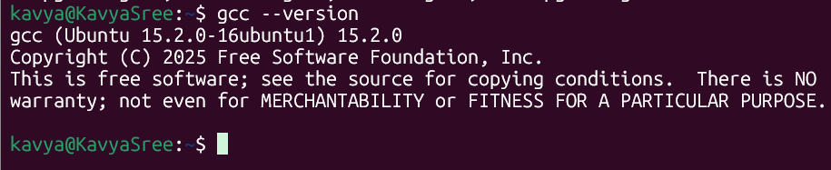

GITHUB REPOSITORY:
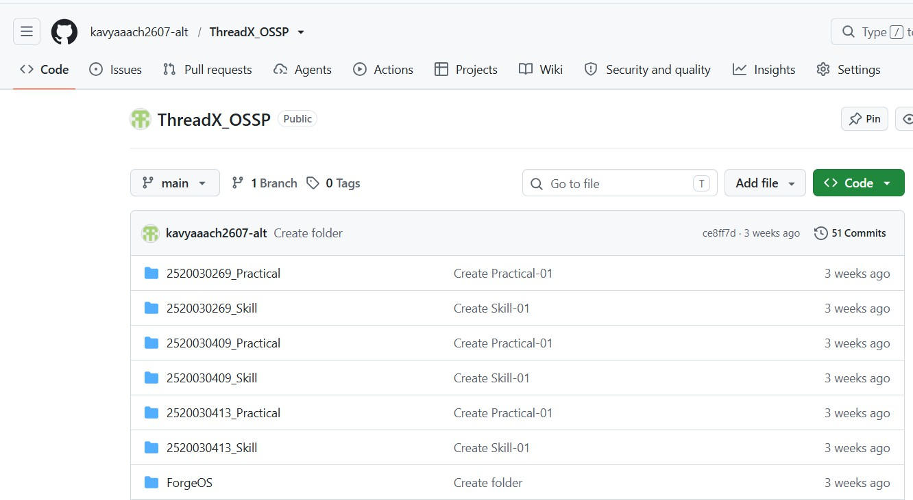

Fork Process:
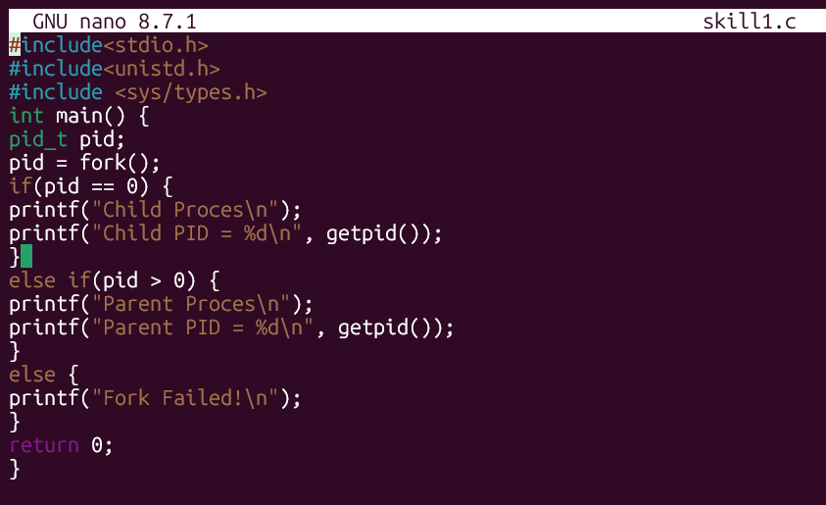

OUTPUT:
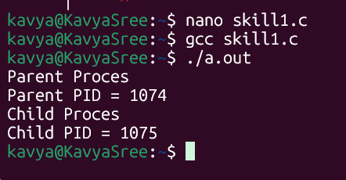

exec() Process:
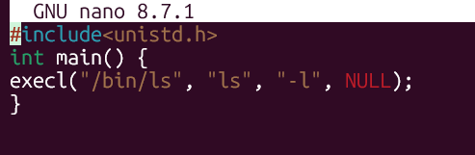

OUTPUT:
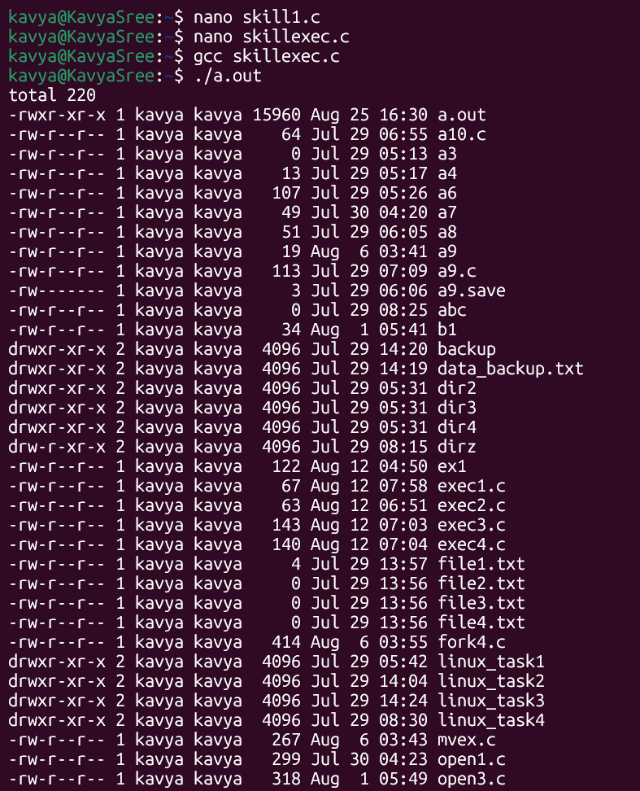

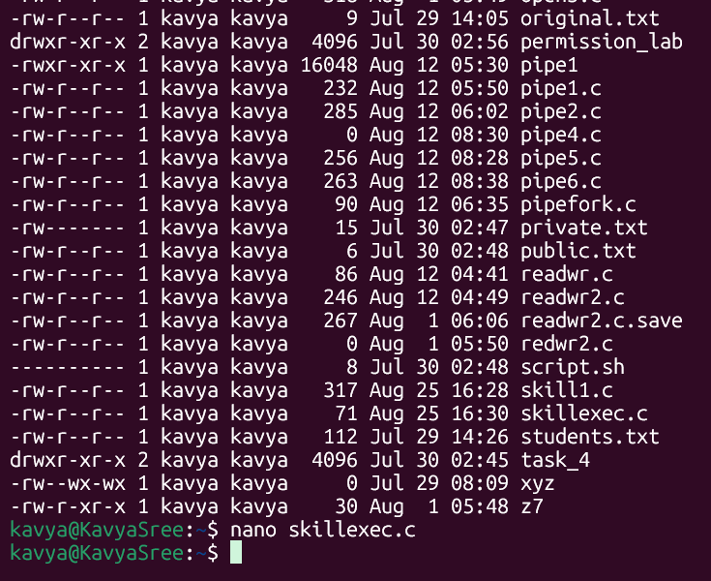

Parent-child Relationship:
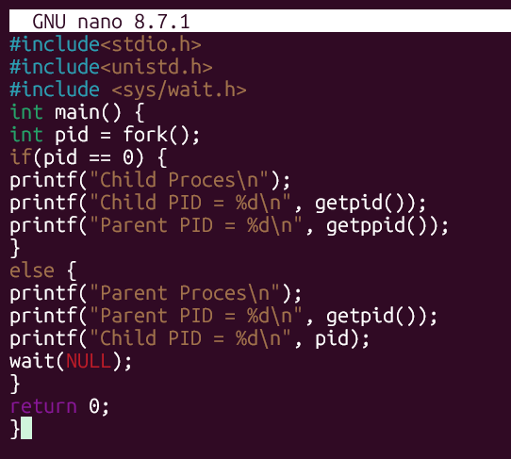

OUTPUT:
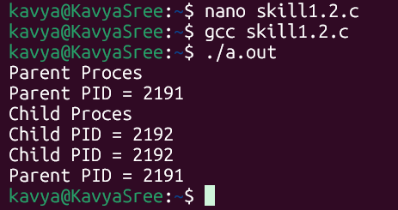

Observation Table:
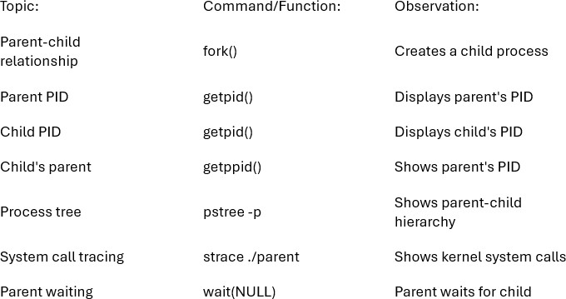

2)
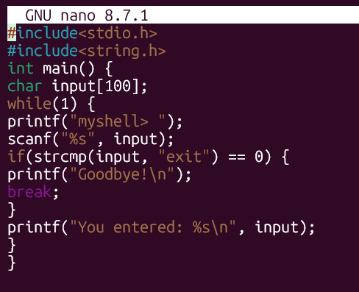

OUTPUT:
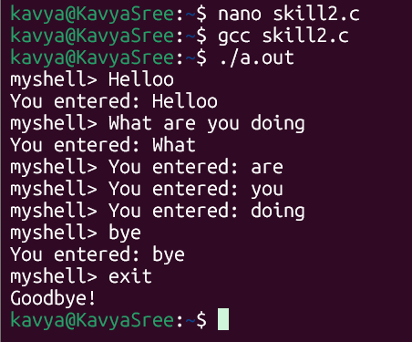

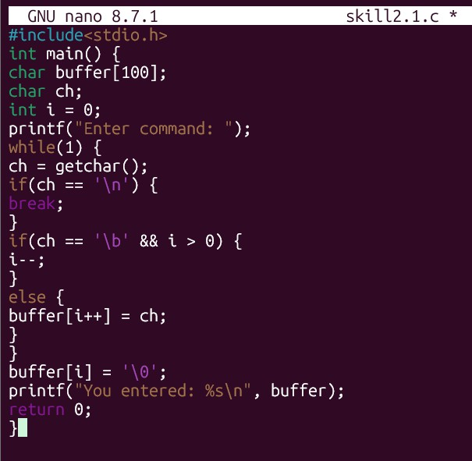

OUTPUT:
